Before we begin configuring the network we must edit the value of PermitRootLogin in the directory /etc/ssh/sshd_config from no to yes in order to be able to connect as root from one machine to another.

Then we restart all the ssh services with the following command :

sudo service ssh restart.

We need to create a pair of private and public key for both machines so the can exchange the public key with one another and be able to communicate .

We use the command

Ssh-keygen -t rsa for the first machine and we leave the passphrase empty

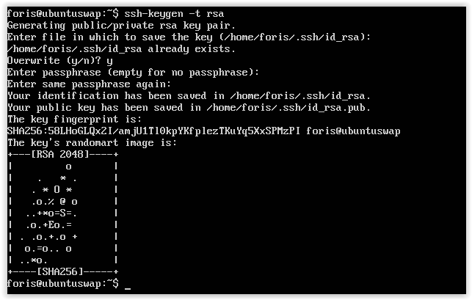

Then we must find the ip of the machine we want connect to

We use to command ifconfig in order to see the Ip of the second machine

When we find the ip we must send the public key of the first machine to the machine we want to connect ,the second one , with the following command :

Ssh-copy-id -I .ssh/id_rsa.pub foris@192.168.56.102

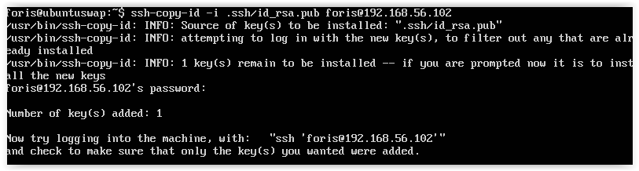

So now the public key of the first machine is known to the second machine and they are able to communicate

We give permission to the authorized_keys

Chmod 600 .ssh/authorized_keys

We connect to the second machine

Ssh foris@192.168.56.102

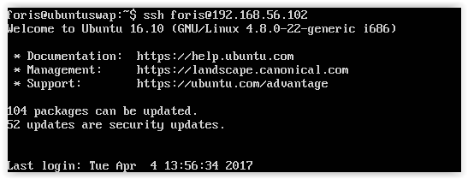

Now that we are connected to the second machine we can create some files to see if it works

As we can see there are no files in the second machine

In the first machine we create one file and we name it test.

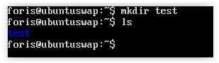

Then we check the second machine and we can see that the file has transfer to the second machine too.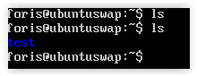

We use the same process for the second machine

Now we need to make copy of the directory /var/www/ .In order to do than we must install the rsync tool.

Sudo apt-get install rsync

Then we sent the folder of the second machine to the first using this command :

Rsync -avz -e ssh foris@192.168.56.102:/var/www/ /var/www/

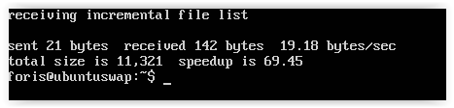

Then we edit the file /etc/crontab in order to make a scheduled process every minute .

So we edit the file 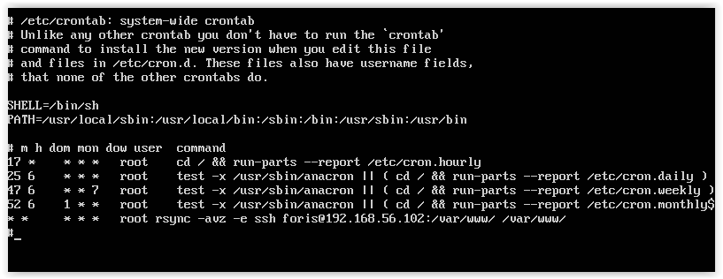

And then we create a file to see if it works

